**Standard Operating Procedure**

**Welding and Cutting Preparation**



**ODISHA MINING CORPORATION LTD.**

**KODINGAMALI BAUXITE MINE**

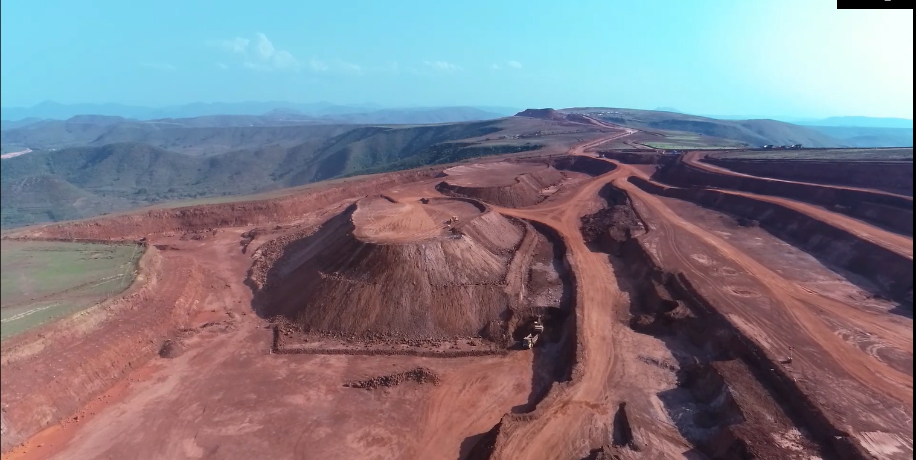

**Authorized By**

1. **Scope and Field of Application:** Procedures establish under this standard is for safe operation during welding and cutting preparation.
2. **Accountability:** Mechanical I/C

|  |  |  |
| --- | --- | --- |
| 1. **PPE:** 2. Safety helmet 3. Safety shoe 4. Nose Mask 5. Safety goggles. 6. Welding Glass 7. Face shield 8. Flame resistant gloved | **Tools:**   1. Vas tools 2. Pliers 3. Channel lock 4. Electric Angle Grinder 5. Circular Saw 6. Reciprocating Saw 7. Torch Kit 8. Tape 9. Welding Cylinders | **Training needs:**   1. Line of Fire 2. Work at height 3. Electrical Safety 4. Usage of PPEs 5. Safe welding operation |

1. **Responsibility:** it shall be the responsibility of mechanical in charge, who shall delegate a workshop in charge. Both shall be responsible for ensuring implementation of this standard.
2. **Procedure:**
3. Carry out welding and flame cutting on the plant only by the authorized persons.
4. Ensure that all required PPE is in good condition and correctly fitted.
5. Before carrying out welding and flame cutting operations, clean the plant and its surroundings from dust and other inflammable substances and make sure the premises are adequately ventilated.
6. Ensure there should not be any damage to welding cable, welding holder, etc.
7. Ensure use of a separate welding cable for earthling up to the welding location.
8. Check for leaks and faults if it is require change the hose pipe and cylinders, never use in leakage condition.
9. Never test for leaks with a flame.
10. Connect the flashback arrester to protect cylinders from flashbacks and back fires.
11. Ensure that, cylinder valve and regulators are clean & dry. No oil and grease are stacked to the valve and regulators.
12. Avoid standing on the hoses or letting it twisted as this may shut off the gas and cause trouble.
13. Never light the torch while both the valves are wide open.
14. Clean the place which is to be welded.
15. Allow the welded parts to cool for same time.
16. Always keep the adjusting valve on the regulator closed when not in use.
17. Keep all cylinders away from heat sources.
18. Keep flammable (Acetylene & LPG) gases away from any source of ignition (NB: any electrical switch is an ignition source).
19. Storage areas should secure against unauthorized entry.
20. Full and Empty cylinders should be stored separately if space permits.
21. Cylinders should not be stored for a long time, rotate stock.